The Real Cost of Student Loans:
Before-tax Thinking in an After-tax World

Jeff Hill, Ph.D., Brigham Young University
Bryan L. Sudweeks, Ph.D., CFA Brigham Young University

ABSTRACT

Perspective is important in managing our finances. Too often, borrowers consider only the after-tax amount borrowed plus interest as the amount they must earn to repay their student and other loans. However, if borrowers consider the pre-tax costs of what they must earn, they will make better decisions. This includes federal, state, and local taxes, as well as savings and other charitable contribution goals. The authors present a framework to help borrowers understand not only how much they must pay back in principle and interest, but including their other costs as well. While the same pre-tax costs will be paid whether the money is saved or borrowed, borrowers should consider the pre-tax costs in determining whether to take out student or other loans as their APR on the pre-tax loan is considerably higher.

INTRODUCTION

Chandler, not his real name, just graduated from a major east coast law school after completing his undergraduate degree at a western university. When he saw me in a restaurant, he said “You taught me about personal finance, but you didn’t teach me about how hard it is to repay student loans.”
Chandler learned an important lesson regarding paying back the student loans—it is more expensive than he thought. There is a major difference between what he borrowed, which is in after tax dollars, and how much he must earn to pay back one dollar of a student loan, which is in pre-tax dollars. He had a rough idea in taking out his student loans what he would need to repay in terms of principle and interest in after-tax dollars. But there are other things he did not consider, and he is not unique. The purpose of this article is to address those other things which are often not understood in paying back student and other loans, which is the importance of that before-tax thinking or perspective.
Start with Taxes
Chandler knows that what he has to earn pre-tax before he can pay back a loan is a function of a number of things: taxes, charitable contributions, and savings. He wants to know how much money he has to earn to pay back one dollar of his student loans.
There are three major taxes that Chandler should be concerned about. First is Federal taxes, the taxes he pays to the Federal government. The second is State taxes, the taxes that go to the State. Finally depending on where he works, there may be city taxes. These are taxes that go to the city or local government.
Chandler knows and understands that the Federal tax rate is progressive, that as his income rises, his tax rate also rises. The important number for Chandler is his marginal tax rate. This is his tax rate on each additional dollar that he earns. The higher his income, the higher his Federal marginal tax rate. Based on Chandler's estimated income, he thinks he will be in the 15% marginal Federal tax rate when he starts work.
Chandler found out that Utah’s tax rate is about 7%. Not all states have taxes on income, but most states do. Chandler knows he needs to take this into account.
Finally, there are a few cities that also have a city tax rate. Thankfully the city he works at in Utah is not one of them.
Chandler knows that in order to pay back one dollar of student loans, he must first pay his Federal, state, and city taxes. Then he will use the remaining money to pay off his student loans.
Chandler now has all the information he needs to calculate the pre-tax or correct cost of his student loans. It's not just principal and interest as most people think, but it's the total amount that he must earn to be able to pay back his loan before taxes.
So Chandlers tax rate is the sum of his Federal, State, and city marginal tax rates; in this case, 15% + 7% or 22%. The formula to calculate how much he must earn is 1 divided by 1 minus the sum of his taxes. In Chandler’s case, 1 divided by .78 (1 – 22%) is 1.28. Chandler will have to earn $1.28 to pay back $1 in student loans (see Chart 1).

Chart 1.
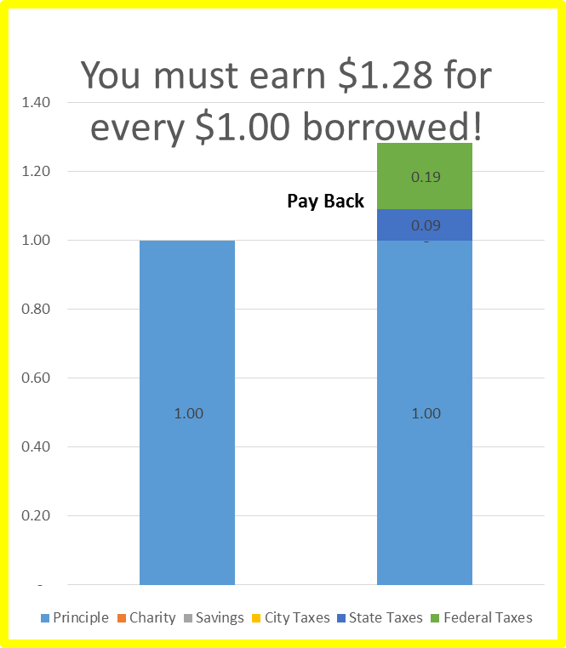

To check this calculation, to pay Federal taxes of 15% of the $1.28 is $0.19, to pay State taxes of 7% on $1.28 is $0.09, and $1.28 minus $0.19 and $.09 leaves exactly the $1.00 needed. For a marginal tax rate of 15% and 7% state, Chandler must earn $1.28 to pay back $1.00 in interest costs.

Add Charity and Savings
However, Chandler has other goals that are important to him but are not required by law. Because he is a Christian, he has set a goal to pay 10% his earnings as tithing and 1% for other contributions. He also has a personal goal to save 15% of his gross income for retirement, a goal that he set during a personal finance class at school. How do these goals impact how much he must earn?
The calculation is the same as for taxes; however, it is the sum of his Federal and State tax rates (22%), his charity rates (11%), and his savings rate (15%), for a total of 48%. 1 divided by 52% (1 – 48%) is $1.92. Chandler must earn $1.92 before he can pay back $1.00 in loans. Now he understands why it is so difficult to pay off his student loans (see Chart 2). He has used after-tax thinking in a before-tax world.

Add in Interest Costs
Chandler knows that the longer he stretches out his student loans, the more he will have to pay in interest costs. So Chandler will try to pay off all his student loans in 60 months after graduation. He knows that his student loans have a low rate of interest that is tax deductible, but the longer he waits to pay them off, the more the more interest he will pay. He wants to pay them off as soon as possible.
Chandler has taken our four Federal Stafford loans of $3,500 each year which are subsidize, i.e., the government pays the interest while he is in school. After graduation, he will pay 6.8% per year. The interest rate is lower and subsidized, which is an important consideration when considering the type of loans. Not all students are this lucky.
Chart 2.
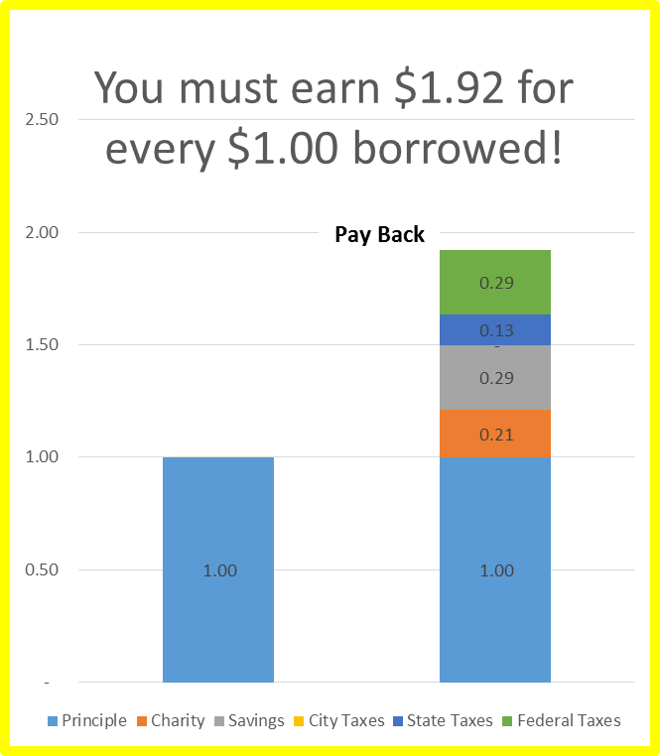

Because all four loans are subsidized, he is looking at only $14,000 in student debt when he graduates. He realizes they are not going to cost him only $14,000, but the principal and interest plus the taxes he will need to earn that amount.
He has determined he will pay the student loans off in 5 years. His payment per loan is $69 per month, times 4 loans is $276. Multiplied times 60 months, he will pay $16,554 in principle and interest over the life of the loans.
However, assuming a tax rate of 15% Federal and 7% State, he will have to earn $1.28 for every dollar he pays back. So instead of the $16,554 for principle and interest, he will need to earn $21,223 to be able to pay back the $16,554. For every dollar chandler borrowed, he will need to earn $1.52 to pay it back. No wonder paying back student loans is difficult.
Now assuming Chandler wants to pay his charitable contributions and pay himself for savings, he must earn the $31,834 or $2.27 for every dollar borrowed. Clearly there are other costs to student loans. While Chandler will have to earn the same amount, whether he borrows or saves, it is critical that he think about these decisions in a pre-tax framework.

Annual Percentage Rate
Now let’s consider Chandler’s APR calculation for this loan. Clearly he has to work longer to earn the additional money for his taxes. In essence, he is paying back more money than he borrowed, as well as paying back more interest. Does this affect his APR calculations for his loans?
He remembers the formula for the APR calculation as his interest plus fees, divided by the number of years, divided by the average amount borrowed. While there needs to be a number of assumptions made for this calculation, clearly since his costs are pre-tax, this will increase his APR significantly.
Chart 3.
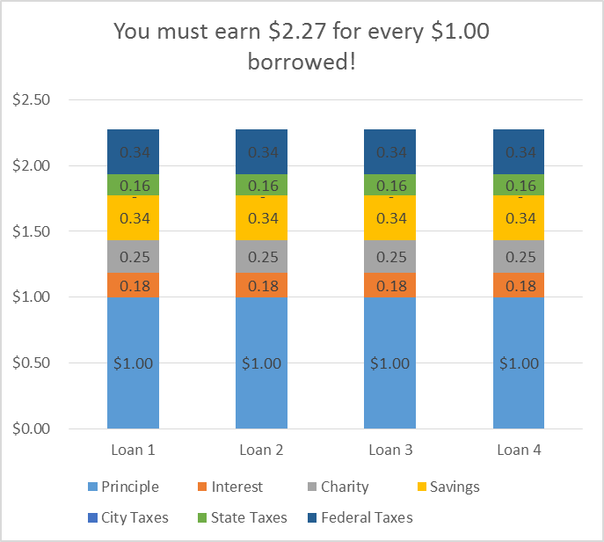

CONCLUSIONS

Student loans have been instrumental in helping Chandler graduate from school. Before, he operated with an after-tax perspective. But now he must pay them back. But with this pre-tax perspective, there are more costs than simply principle and interest. He must earn enough to pay for his taxes and other contributions before he can begin to pay off his debts. This brings up a few implications of this analysis.
- Borrowers should be careful to use this pre-tax perspective, which increases their APR. They should cautious to ensure that the salary from their desired job after their education is sufficiently high enough to pay back their student loans. I have heard of students who graduate with $200,000 in student loan debt on a teacher’s salary. That will be very difficult to pay back and will impact their lifestyle for many years.
- Borrowers should be careful not to confuse after-tax and pre-tax amounts, and should be wise in their use of student loan debt. They need to realize that if they are paying $1.52 for every dollar borrowed, that if they are paying $500 for rent, it's really costing them $760, and that $3.00 per gallon of gas that were borrowing to go to school, is really costing them $4.56. Borrowers should look at the total amount they must earn to pay down their debt, their pre-tax amount. Debt should be used sparingly.
- Some have said that it is OK to go into debt for education. While I know this is true, borrowers should be wise in that debt and should strive to minimize it as much as possible and consider their pre-tax perspective.
- There are also policy implications as well. If the government is truly concerned about student loan debt, this information on the pre-tax costs of paying back loans should be taught more widely.
- Finally, if governments truly want to help the students, reducing Federal and state taxes is a great way to begin.
The total cost of student loans is not just the after-tax principle and interest costs, but the total amount students must earn to have the money necessary to pay off the loan, the pre-tax amount. Chandler learned that it is significantly more than the amount he borrowed.

EXCEL SPREADSHEET

We have developed an Excel spreadsheet “Loan Amounts to Pay Back (LT34).xlsx” to help you with these calculations. This spreadsheet can be found at the BYU Marriott School of Management Personal Finance website at http://personalfinance.byu.edu/content/learning-tools under Mortgage and Debt Reduction Tools.

