Exploring Accounting and Financial Controversies via an Excel Simulation Exercise

Khalid Razaki, Dominican University
Anne Drougas, Dominican University
Robert Irons, Elmira College

ABSTRACT

Successful accounting and finance practitioners position themselves as global business advisors, who utilize software and technical material as a platform to navigate through different cultural practices, institutional rules and regulations. While studies still suggest that a disconnect exists between academia and practice when preparing student for the, professional regulatory bodies, such as the Association to Advance Collegiate Schools of Business (AACSB) and the American Accounting Association Pathways Commission, strongly advocate for the “development of signature pedagogies” which connect the mission of the business school and learning outcomes in support of a globally-diverse student body. This paper describes the development of a spreadsheet exercise which connects mission to the finance and accounting curriculum at a small, private AACSB-accredited business school. In keeping with the institution’s charge of infusing technology, international issues, and mission into required coursework, finance and accounting faculty leverage a controversial issue, tax avoidance policy, to examine the impact of the locational choice of a subsidiary on financial statement analysis, and key financial indicators. Tax avoidance and transfer pricing policies serve to develop cultural awareness in accounting and finance students while stressing solid financial statement fundamentals and pro forma financial statement development.

INTRODUCTION

How do educators deliver pedagogical value to business students yet prepare students for ethics-centered careers (O’Leary, 2009; Sweeney and Costello, 2009; Phillips and Graeff, 2014; Patel, Millanta, Tweedie, 2016)? AACSB International (2011) suggested that business schools should pay more attention to preparing students to interact and gain experience with business practices different from their native country; however, Shooshtari and Manuel (2014) question whether academics possess the classroom time to do it. Can a business curriculum train students “to develop a global mindset” and still provide those students the technical training necessary to attain employment and professional certifications (Tucker and Lowe, 2014; Barker, Asare, and Brickman, 2016; Botes and Sharma, 2017). While several academic papers suggest this can be done effectively (Choi and Liu, 2013; Lafond, McAleer, and Wentzel, 2016; West, 2017), creating assignments and projects underscores the pedagogical “tug-of-war” between dedicating time towards discipline-specific content (Tucker and Lowe, 2014; Barker, Asare, and Brickman, 2016; Botes and Sharma, 2017) and preparing students to think strategically in a global context (Hise & Koeplin, 2010; Holmes, Wilkins, & Zhang, 2017; Karmakar & Mukherjee, 2017), rather than arrive at a single, numerical answer. This paper presents an example of how a controversial topic, such as tax avoidance, can be used as a vehicle to examine important pedagogical linkages in the curriculum, such as technology, foreign exchange rates, and financial statement analysis.

LITERATURE REVIEW

Lakshmi (2016) suggests that popular introductory financial textbooks (e.g., Arnold, 2013; Atrill, 2009; Bodie, Kane, & Marcus, 2013; Brealey, Myers, & Allen, 2013; Hillier, Ross, Westerfield, Jaffe, & Jordan, 2012) have only changed marginally over the past years and do not adequately reflect globalization or more timely topics, such as crowd funding, nonprofit finance and accounting. Finance is a vital component of the accounting curriculum and while most finance courses incorporate ethics (Boatright, 2013; Giacalone & Thompson, 2006; Laskshmi, 2016), existing curricular objectives tend to more strongly support the technical side of finance. This includes value maximization principles, time value of money, and quantitative techniques for assessing risk and return. Lakshmi (2016), Lorsch (et. al, 2008), and Podolny (et al., 2009) advocate for a “pedagogical toolset” which injects a “conscience” into the profession, particularly at the introductory level. By leveraging common language and core principles with financial accounting, managerial accounting, and corporate finance courses, issues such as tax avoidance could be debated, creating linkages to liberal arts education (Van der Wende, 2014) and injecting human behavior and practical applications into the technical toolset (Botes & Sharma, 2017; Pathways Commission, 2012; Teal & Krishman, 2011; Tucker & Lowe, 2014).
Concepts such as tax havens, tax avoidance theory, and international taxation policy are often viewed as playing the role of the villain with respect to federal budget deficits, GDP growth, and production (Hebous, 2014). Yet, others suggest that designing accounting practices to reduce taxes is “normal” (Sikka, 2015); Therefore, introducing controversial international taxation issues and transfer pricing within business courses resonates with the millennial generation and underscores the importance of conducting business across borders in several ways (Nebus, 2016). First, roughly 73% of Fortune 500 companies maintain subsidiaries in offshore tax havens and roughly thirty of those companies are responsible for 66% of the $2.5 trillion held by offshore subsidiaries (Phillips, et al., 2016). With a millennial generation more concerned about social justice and corporate responsibility (Deloitte Millennial Survey, 2017), exploring the tax haven structures of Apple, Google, Nike, and Goldman Sachs sparks student interest particularly when they learn that U.S. corporations avoided paying $717.8 billion in U.S. taxes in 2015 due to tax havens (Markle, 2016; Olibe, 2017; Phillips, et al., 2016).
Second, millennials believe that large multinational firms are not “fulfilling their potential to alleviate society’s challenges” (Deloitte Millennial Survey, 2017) yet favorable tax treatment for multinational corporations necessarily leads to concerns about smaller domestic companies, which in turn are paying a disproportionate share of the taxes due to tax avoidance and transfer pricing (Clausing, 2016; Markle & Shackelford, 2009; Olibe, 2017; Sheppard, 2010). Students are exposed to corporations of interest to them, such as Google, which was charged with deliberately understating its profits by charging its UK operations too much for the use of overseas-owned intellectual property. The UK government responded by threatening to impose the measure that has become known as the “Google tax”. It represents a revolution in tax policy, to the extent that it introduces the idea that the volume of sales in a particular country should determine the tax paid in that country (Clausing, 2016). Students develop a greater world view of why large corporations open subsidiaries in countries such as Netherlands, Ireland, Luxembourg, Bermuda, Switzerland, Singapore, and the UK Caribbean Islands (including the Caymans). In addition, students learn that foreign investors can invest money in the United States with no taxation of interest or capital gains, and without being reported to their home governments (Mitchell, 2006).
Third, studies suggest that international tax issues (e.g., tax havens, transfer pricing) present provocative classroom discussions regarding profits attributing to the multinational corporations and whether it is ethical to utilize the tax laws to do so (Fuest, et al., 2013; Phillips, et al., 2016). However, academics have found it difficult to publish pedagogical and strategy articles in tax policy, possibly because journal editors view this area as more “practitioner” in nature (Nebus, 2016; Phillips, et al., 2016). In order to connect the practitioner topic with academic learning, simulation modeling and interactive spreadsheets can be employed within a classroom to examine the impact of tax avoidance and transfer pricing on subsidiary financials and profits. Specifically, Ramachandran and Ragland (2016) identified a lack in the accounting pedagogical literature with respect to technology; possible disconnections exist between Excel skills faculty include in the accounting curriculum and specific Excel skills faculty believe new hires (i.e. recent accounting graduates) most often use in public accounting. While spreadsheet programs like Excel provide powerful, analytical tools for assessing businesses, Frownfelter-Lohrke (2017) suggest that many Excel-based activities in the accounting curriculum do not allow students to reflect upon their results and fewer still are international in scope. Students make critical errors in spreadsheets without analyzing the reasonableness of their results.
McWilliams and Peters (2012) emphasized that course content within finance and accounting disciplines should naturally flow together via financial statement analysis, ratio analysis, and technology; however, both are often taught separately with little cross-communication among faculty. In addition, many programs limit the financial statement analysis of international expansion and the impact of foreign exchange rates to upper division advanced accounting courses. This article intends to describe an integrative Excel-based exercise and simulation model which allows the accounting and finance students to explore how decisions regarding foreign exchange levels and the relationships between various financial statement components and sales will impact a firm’s profitability, net worth, fundamental financial ratios, and economic value added (EVA). The simulation exercise emphasizes skill sets in application to relevant global issues, such as international tax loopholes, which impact profit and firm value.

COURSE DESCRIPTION AND LEARNING OBJECTIVES

The spreadsheet exercise was introduced within a required MBA finance course, with prerequisites of financial accounting, managerial accounting, and business statistics. The specific course is required for all business students and serves as a launching point into strategic management, international finance, investment analysis, and international marketing.
The required MBA corporate finance course includes time value of money, financial statement analysis, bond and stock valuation, corporate governance, risk and return, capital budgeting, and select topics on initial public offerings, multinational finance, and mergers and acquisitions. As part of this course, student teams have traditionally adopted a firm and reviewed its annual report, assessed its bond and intrinsic stock price and calculated WACC for firms in the Dow Jones Industrial Average. As part of the course, student teams prepare papers every two to three weeks which assess their company using the tools and techniques of the chapter being studied at that point in the course.
In Fall 2016, students were provided the offshore tax avoidance report by Phillips (et al., 2016) and McIntyre (et al., 2015) in the first week of the semester, which lists the top twenty Fortune 500 companies with the most tax haven subsidiaries, along with the locations of those subsidiaries. For example, students learn that, in 2015, Bank of America has 109 subsidiaries, which include the Cayman Islands (18), the Netherlands (25), Luxembourg (8), and Ireland (3). Students formulated teams of two or three, and in addition to preparing assignments on financial statement analysis and required financial components for their company, the last module of the course infused tax avoidance with multinational finance and corporate governance. Students integrated the financials of the parent corporation (e.g., Bank of America) into a prepackaged Excel simulation template, selected two subsidiary locations, and investigated the impact of the location of that subsidiary on financial statement items.
Learning objectives include:
- To stress the increasing importance of international operations on financial reporting, centering on controversial issues.
- To develop a broad based tool for satisfying curriculum and assessment goals regarding globalization
- To review fundamental concepts regarding consolidated financial statement construction
- To reinforce student appreciation for the connection between the income statement, the statement of retained earnings and the balance sheet
- To review how foreign exchange rates are used to “translate” the financial statements of foreign subsidiaries under generally accepted accounting principles

TAX AVOIDANCE AND TRANSFER PRICING: WHAT DOES THE RESEARCH SHOW?

Required MBA finance courses emphasize the importance of discounted cash flow and future free cash flows as measures of a firm’s intrinsic value. While standard corporate finance texts do include mention of the impact of taxation on the risk of cash flows, priority is usually given to other topics and very few textbooks address controversial topics (Lakshmi, 2016). Students preparing for careers in financial management, particularly at U.S. multinational corporations, may not be exposed to simple tax implications which may impact business decisions, and the controversies (or ethical underpinnings) associated with those decisions.

Tax Deferrals, Havens, and Piggy Banks

Before presenting students with the spreadsheet simulation, students are exposed to the key terms and topics in the tax avoidance and transfer pricing literature via research papers and popular press articles. Russell and Brock (2016) broadly define tax avoidance as stemming from any policy, activity, or transaction that reduce “the total amount of explicit taxes paid by an individual or organization.” Tax reducing strategies are not necessarily abusive; however, strategies can become abusive if they violate the intent or spirit of the law. For example, students learn that most U.S. multinational firms accumulate their foreign business income in foreign subsidiaries, what Boise (2007) refers to as “piggy banks.” This action is known as a “deferral,” as it allows the firm to defer the U.S. residual tax on their foreign earnings until those earnings are transferred to the U.S. parent company. In practice, this means that U.S. multinational corporations (MNCs) can defer the American tax on the profits.
By all accounts, deferrals have become a significant strategic objective for such firms. As of the third quarter of 2005, an estimated $650 billion in foreign earnings was being held by offshore foreign subsidiaries of U.S. corporations (Boise, 2007). This increased to more than $2 trillion by 2015 (Shapiro & Mathur, 2015).
The term “deferral” implies that the U.S. taxes will eventually be paid, as if the tax revenue is not lost, that it is just an issue of timing. This is simply not true. First, some U.S. corporations can deploy those earnings offshore and never repatriate them to the USA. However, even if the funds are eventually repatriated, extensive deferrals can make the present value of the funds approach zero. In either case, the end result is not a tax deferral, but rather a tax exemption. The report for fiscal year 2007 by the Office of Budget and Management estimated that deferrals would likely cost the government $68 billion in lost tax revenue between 2007 and 2011 (Boise, 2007).

Motivations for Avoidance: Corporate Culture and Ethical Underpinnings

Joulfaian (2000) shows that managerial preferences have a significant impact on a firm’s compliance (or noncompliance) with the corporate income tax. His results indicate that noncompliant firms are three times more likely to be managed by executives who have understated their personal taxes, irrespective of firm size. His findings also suggest that the amount of under-reported income is significantly higher for firms run by such executives.
Like the culture, the firm's attitude toward taxes flows down from the top. A survey of executives of U.S. multinationals found that 44 percent said that they avoid repatriation taxes by borrowing funds in the United States rather than transferring funds from foreign subsidiaries, and nearly 20 percent said their company invested its foreign earnings in overseas assets with a lower return than they could have earned in the United States (Clausing, 2016).
Lastly, Crane and Nourzad (1990) reveal that tax evaders respond to higher marginal tax rates by increasing their evasion activities, and also that individuals with higher levels of income tend to evade more in taxes. Yet, when studying the owners of the firms instead of the managers, DeBacker (et. al, 2015) finds that the influence of corruption diminishes as firm size increases. This suggests to students that stronger separation between ownership and control, particularly in larger firms, underscore the importance of corporate governance in business core courses (DeBacker, et. al, 2015). Taken in conjunction with the findings by Fisman and Miguel (2007) and Joulfaian (2000), these results support the conclusion that it is the personal behavior and attitudes of the top executives that drive corporate tax avoidance efforts. Even corporations with owners from countries considered more corrupt evade taxes in the United States, particularly when the firm is smaller, as measured by total assets.

TRANSFER PRICING AND TAX HAVENS

While transfer pricing theory is prevalent within accounting textbooks, its application with respect to tax avoidance has gained little traction, particularly in pedagogical business journals (Sikka & Willmont, 2010). Given the explosive growth in global trade and the rapidly increasing internationalization and intermarriage of worldwide corporate activities, and the concurrent need of nation states to partially fund their financial needs through corporate taxation, the issue of transfer pricing is reassuming its importance. Leone (2011) reports that million dollar tax disputes with large corporations like Xlinix and GlaxoSmithKline with the U.S. Internal Revenue Service suggest that transfer pricing is a topic which should be included within the business curriculum. Simply put, a “transfer price” is the internal price charged within a corporate entity’s various segments or sub-entities for all kinds of goods and services. The problem arises because different tax jurisdictions (mostly nation states or regional economic alliances) have differing tax regimes and regulatory capacities.
Sheppard (2010) suggest that media use the term transfer pricing interchangeably with the practice by multinational corporations (MNCs) of shifting profits to tax havens in an effort to avoid taxation. It is widely suspected that large corporations use the aggressive transfer pricing for within-firm transactions in order to reduce their tax obligations (Desai et al., 2006; Egger et al., 2010).
Sikka and Willmott (2010) also report that public accounting firms, like KPMG, report that transfer pricing is used to successfully reduce tax obligations and maximize profits for their clients. PriceWaterhouseCoopers, Grant Thorton, and Deloitte and Touche all utilize complicated transfer pricing transactions with their clients; with the pending fruition of the UK’s government proposal to make transparent transfer pricing schemes, Sikka (2015) reports that initiatives like those suggest by the UK will make the UK less competitive.
INTEGRATIVE EXCEL SPREADSHEET: SIMULATION STRUCTURE

After preparing financial statement analysis, bond and stock valuation, and WACC calculation for their firm listed on the Offshore Shell Games Report (Phillips, et al., 2016), student teams are ready to utilize the interactive spreadsheet to assess the impact of changes in foreign currency exchange rates, tax rates, and subsidiary location on key financial metrics (e.g., liquidity ratios, working capital, EVA). This section presents the Excel-based spreadsheet for translating financial statements of two subsidiaries for a fictitious firm. The initial spreadsheet is divided into three parts, each representing various points in time during the translation process. A copy of the integrated spreadsheet, as well as the simulation model, can be obtained from the corresponding author.
In this example, the parent corporation has established two subsidiaries in the Cayman Islands (Subsidiary 1) and Luxembourg (Subsidiary 2) on January 1st of fiscal year 20X1 and is attempting to assess the impact of each subsidiary’s financial statements on the consolidated statements of the parent corporation. The development of the spreadsheet model consists of several steps – with the baseline model being utilized in scenario analysis and, subsequently, in a simulation exercise – based on the percentage of sales method.
Student teams selected Cayman Islands and Luxembourg for a variety of reasons. Thompson (2015) disclosed that companies like IKEA and Abbott Labs were taking advantage of tax havens in Luxembourg, citing three buildings in Luxembourg representing the mail addresses of roughly 4,000 subsidiaries. While Luxembourg’s corporate tax rate is roughly 25%, its government offers many tax breaks which vary from firm to firm, possibly reducing that corporate rate to 5% (Erb, 2014; Thompson, 2015; Worstall, 2015). In addition, the Cayman Islands is perceived as a key Latin American business hub and has a zero effective tax rate. Both the Cayman Islands and Luxembourg were subsidiaries for major Fortune 500 companies (Phillips, et al., 2016).

Master Input Page and Date of Acquisitions

The simulation consists of thirteen interactive worksheets. Figure 1 presents the master input page where students make decisions regarding exchange rates, expected sales, operating income, and other key financial statement items in the simulation. These assumptions are then used to calculate the financial statements for year 20X2 for each legal entity individually. Key considerations include the following
- Exchange rates should be entered as indirect quotes (i.e. the quantity of foreign currency required to exchange one USD). The exchange rates are required to be entered as of December 20X2 under two scenarios: worst case scenario and best case scenario. The average exchange rates during 20X2 are not required to be entered because they will be calculated by using the exchange rates at end of year 20X1 and 20X2.
- Students are expected to estimate the effective tax rates for all entities and the pay-out ratio for parent company. If the parent company will not distribute cash dividends, the pay-out ratio should be 0%.
- Expected sales and annual growth in operating income are required to be estimated under worst and best case scenarios. These estimations should be entered using the functional currency for each entity. Because the annual growth in operating income is one of the key factors in enterprise evaluation, instructors should work with students to ensure that the annual growth in operating income does not exceed the weighted average cost of capital (WACC). This should avoid any technical problem with the simulation model.
- Financial statements structure: these indicators are required to be estimated in order to create the needed financial statements. Keep in your mind that these indicators should be reasonable and attainable in order to create realistic pro forma financial statements.
- The cost of capital matrix provides a pathway for evaluating a firm’s optimal structure. It also may reinforce discussion as to whether firms operate at their optimal capital structure. However, instructors may wish to lock this matrix if the simulation is implemented in less advanced major course.
- Special transactions and transfer pricing may be included in the simulation.

Figure 1: Master Input Sheet

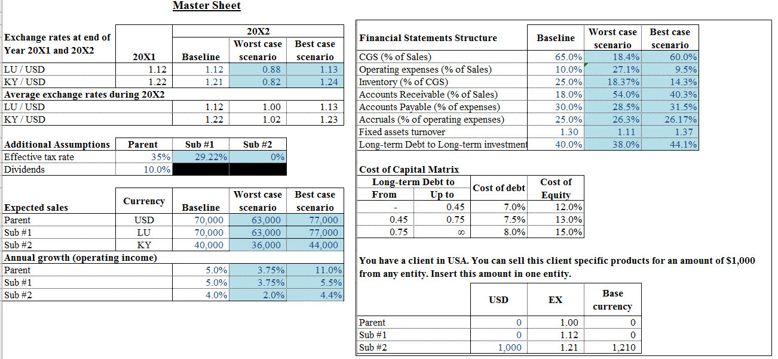

In addition, students alter expectations with respect to key financial statement items to define a baseline, worst case, and best case scenario. The simulation assumes that the difference between assets and sources of funding (liabilities and equity) is reported as cash and cash equivalent. Therefore, students will need to review the spreadsheet with the instructor to ensure that cash is within an acceptable range. If students discover that the cash balance is above an acceptable level, the student can adjust long-term debt and long-term investments gradually to define more reasonable assumptions.

Financial Statements for the Parent and Subsidiaries

The financial statements are presented for the parent (Figure 2), the first subsidiary (Figure 3), and the second subsidiary (Figure 4) by using the functional currency of each entity. Each balance sheet consists of four columns displaying the current balance sheet (20X1), baseline scenario (20X2), worst case scenario (20X2), and best case scenario (20X2). The income statement and statement of retained earnings also consists of the same three columns.
The baseline model consists of three sections: the date of acquisition, subsequent acquisition, and the translated subsidiary statements. Lastly, students determine the dollar value of specific products sold from any entity. On the date of acquiring the Irish (Subsidiary 1) and Luxembourg (Subsidiary 2) firm, it is initially assumed that the parent corporation purchases each subsidiary for US$25,000 and US$40,000 respectively.

Figure 2: Parent Corporation Financial Statements (20X1 and 20X2)
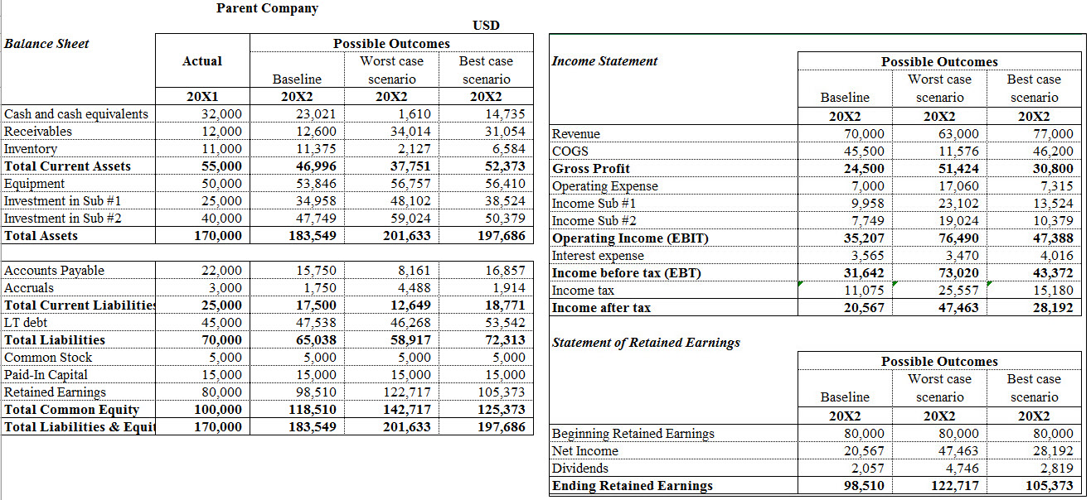

It is assumed that the initial purchase price for both subsidiaries appears as a credit on the date of acquisition (‘=F10 and ‘=F11) and that the difference between the initial purchase price and its book value (‘=E13) was debited to goodwill. Generally, this section of the spreadsheet is static in nature and may be used by an instructor to reinforce relationships between debits and credits as well as functional relationships between assets and liabilities.

Figure 3: Subsidiary #1 Financial Statements (20X1 and 20X2)

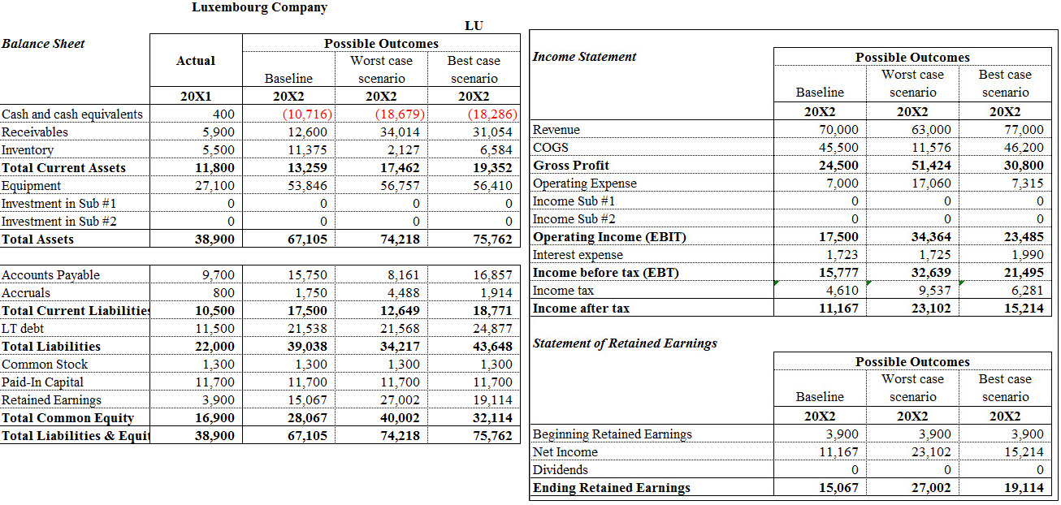

Figure 4: Subsidiary #2 Financial Statements (20X1 and 20X2)

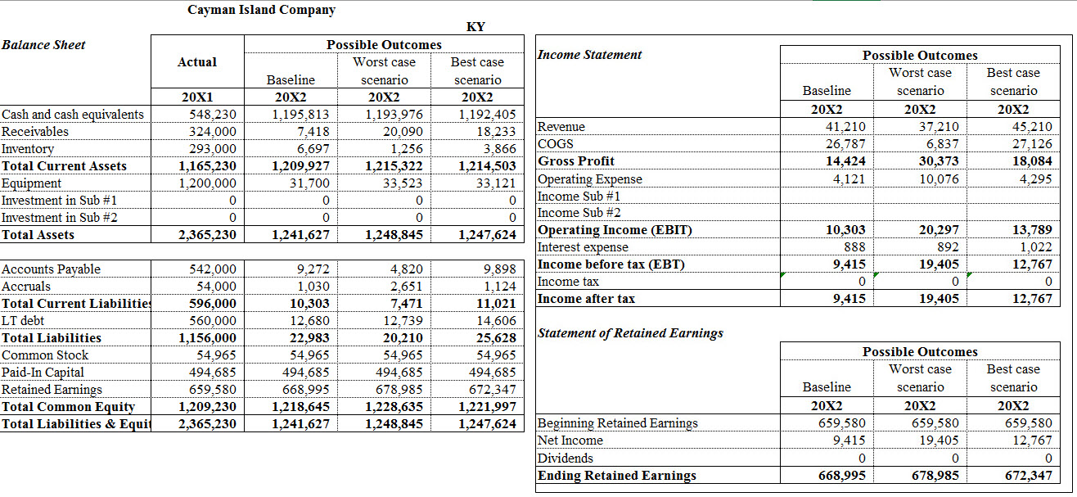

Consolidated Financial Statements
Figure 5 presents the consolidated financial statements balance sheet in United States dollars in December 20X1. It also includes elimination entries which eliminate the common equity of the subsidiaries with the investment in first and second subsidiaries. Since the net assets’ fair value equals the book value, the simulation assumes that the difference between the subsidiaries’ common equity and the subsidiaries’ investments is reported as good will. In the baseline case, both subsidiaries base financial statement items as a percentage of sales. All percentages may be varied in order to emphasize how assets and liabilities are affected by changes in working capital or additional financing. Figure 6 and Figure 7 present the consolidated financial statements (with debits and credits) and the financial analysis for the baseline case, including WACC and EVA.

Figure 5: Consolidated Financial Statements (20X1)
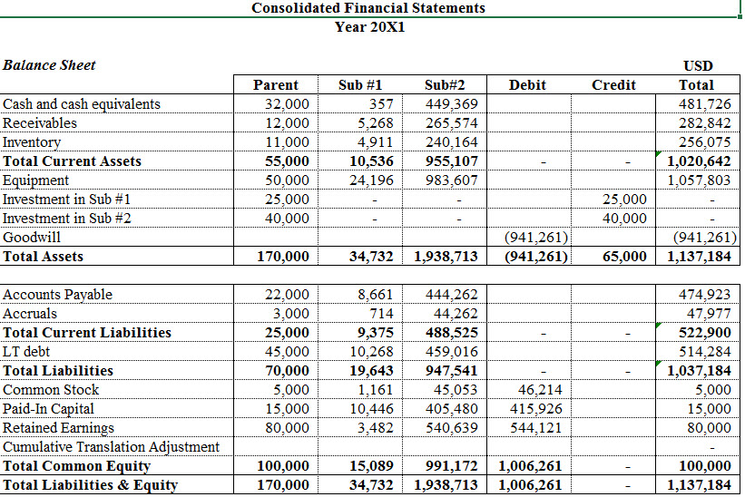

Figure 6: Consolidated Financial Statements (Baseline Scenario, Year 20X2)

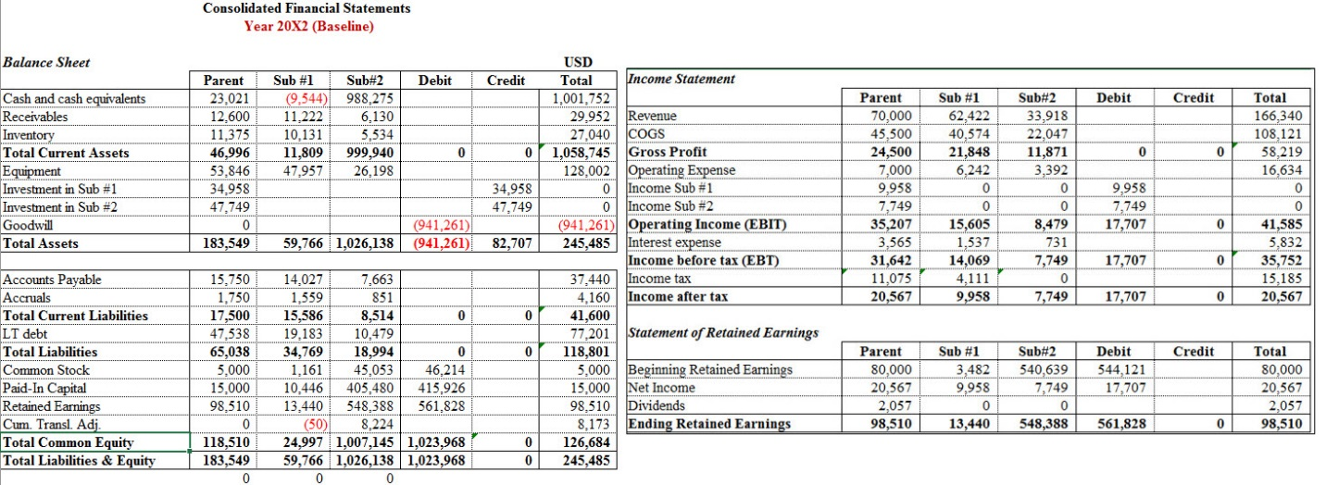

Figure 7: Consolidated Financial Analysis (Baseline Scenario, Year 20X2)
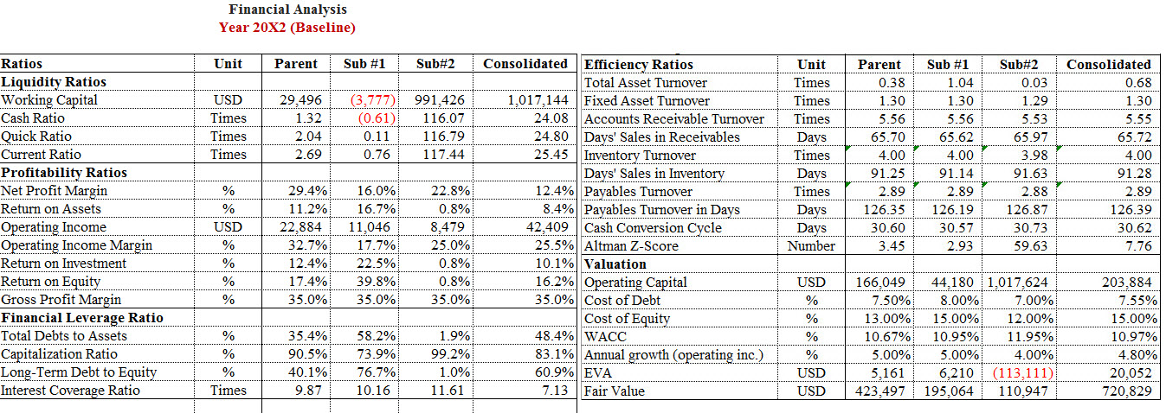

Comparative Consolidated Financial Statements and Financial Analysis (20X2)

Utilizing student inputs, the Excel spreadsheet generates consolidated financial statements (e.g., balance sheet, income statement, and statement of retained earnings), and a secondary worksheet which summarizes key financial ratios, including weighted average cost of capital (WACC), working capital, and economic value added (EVA). The financial analysis sheet presents the most common ratio analysis at two levels: the stand-alone level (i.e. Parent, subsidiary #1, and subsidiary #2) and the consolidated level. In this area, students are highly recommended to think about the difference in some ratios between the consolidated level and stand-alone level such as net profit margin. Figure 7 presents the consolidated financial statements and the financial analysis for the Year 20X2, baseline case results. Figure 8 presents key ratio analysis, including weighted average cost of capital (WACC) and economic value added (EVA) for the baseline case.

Figure 8: Comparative Consolidated Financial Statements (Year 20X2)
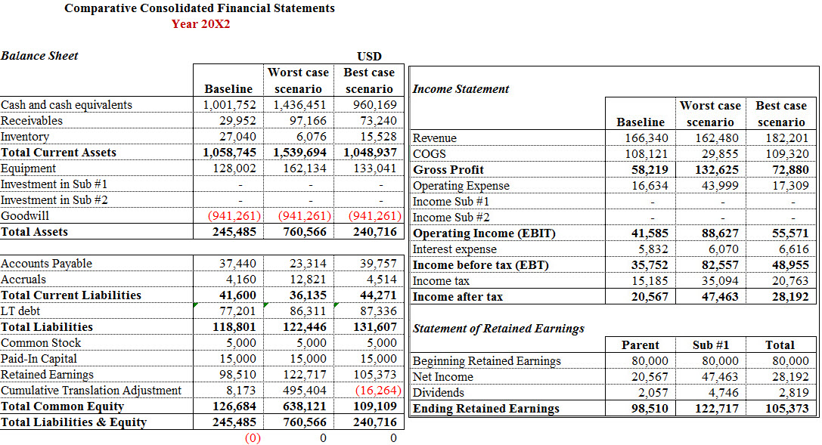

Figure 9: Financial Analysis
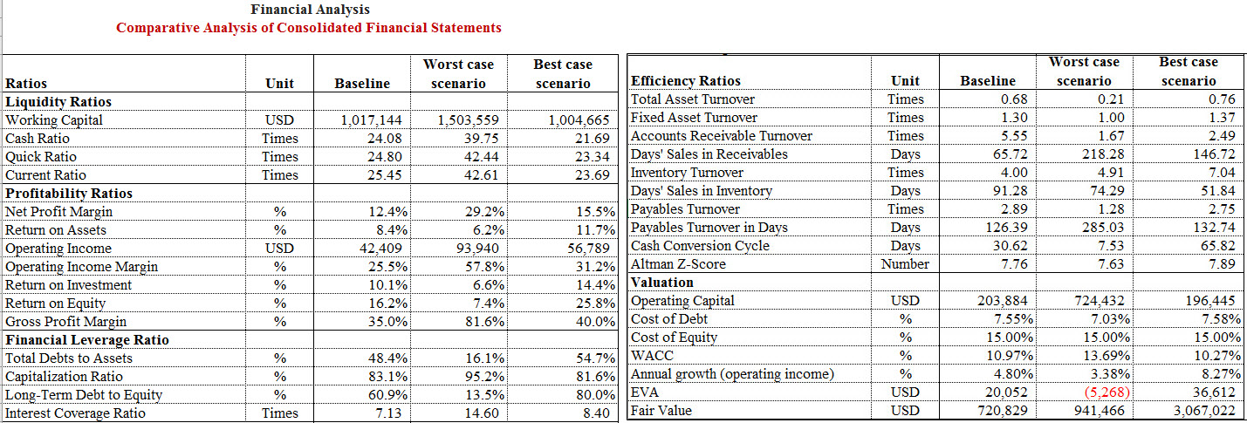

STUDENT RESULTS AND LESSONS LEARNED

Student results reinforced key accounting and financial principles, such as how goodwill is generated on the financial statements and how tests of impairment have replaced systematic amortization. In addition, student results triggered discussions regarding how foreign exchange rates are used to “translate” the financial statements of foreign subsidiaries under generally accepted accounting principles.
The figures presented represent one student team’s results involving the two subsidiary creations of a Fortune 500 company in the Cayman Islands and Luxembourg. The “affordability” of locating a subsidiary in the Cayman Islands (exchange rate of $1.22, effective tax rate of 0%) and Luxembourg (exchange rate of $1.12, effective tax rate of 29.22%) was surprising to students. Students noted the increases in accounts receivable, current assets, and retained earnings. The creation of subsidiaries appeared to be associated with higher profit margins and improved earnings per share (Khan, Srinivasan, & Tan, 2017).
In the worst case scenario, student teams discovered that the subsidiary did not improve profitability for the parent corporation. After reviewing the financial items, gross profits, operating income (EBIT), EBT, income after tax, and retained earnings all decreased from the baseline. Looking at the ratios the gross profit margin decreased from 35% to 30% showing that in the worst case scenario they are not able to better control their costs. And the net profit margin, also decreased from 12.4% to 9.3 % showing that profits earned by the subsidiary are declining. Lastly, the students surmised that the subsidiary was less efficient at converting revenue to profit (comparative analysis sheet).
In the best case scenario, the Cayman Islands offers the highest amount of profit and the least amount of risk. Also Luxembourg, while having a slightly lower effective tax rate, contributes a large percentage of the revenue gained by the parent company. According to the student team, the best case scenario, with both subsidiaries, results in higher revenue and higher profit margins. They also commented on lower common equity, and increased liabilities as a result of increased financial leveraging, confirming the idea that companies have a motivation to raise leverage above the optimal level without taxation due to the deductibility of interest on debt from the tax base whereas the return on equity does not allow that deductibility, overall growth is nearly double that of the baseline (Egger, et al., 2010).
Lastly, the student team assumed that the parent corporation had a client in the USA and you can sell this client specific products for an amount of $1,000 from the Cayman Island subsidiary. When considering the impact of this client on the consolidated financial statements, student teams discovered that the parent corporation’s after-tax income increased due to the strategy. Although a very simple application of transfer pricing, the student team confirmed concepts presented by Contractor (2016), companies “pay higher amounts” to affiliates where taxes are lower and utilize international supply chains to ship goods and services, taking advantage of tax avoidance policies.
For some student teams, there was a supposed ethical issue of whether or not subsidiaries are moral because they capitalize on tax avoidance policies. However, many student teams were quick to point out that, according to the US government, subsidiaries are not illegal as long as a firm discloses all the information. For that reason, many student teams believed that while some might consider it unethical, a firm’s priority was to maximize shareholder wealth and there is a difference between tax avoidance and policy abuse.

CONCLUSION AND FUTURE RECOMMENDATIONS

While medical mistakes can be spotted very quickly, poor corporate governance in the finance and accounting professions are slow to unravel (Lakshmi, 2016). The direction of the university finance and accounting educational systems appears to be supported by quantitative and econometric analysis and student support in preparation for professional certifications; yet, university professors spend so much time focusing on the techniques and tools in assessing risk management practices, options and derivatives, and modern portfolio theory that they may be providing a disservice to finance and accounting students preparing for positions where value judgments are necessary. Team projects integrating technology and quantitative techniques which can yield multiple solutions may help create student “sustainable networks” which help prepare students for realistic solutions for issues they may face in real world settings (Capra, 2005). This is particularly true when managers are not present and an accounting and finance professional must make the decision for a client rather quickly.
The accounting and finance disciplines are as much a science as they are an art (Vollmer, Mennicken, & Preda, 2009). If university professors can begin to create more stylistic assignments and projects based upon world events and controversial topics, such as tax avoidance and transfer pricing, students preparing for careers in the profession may develop the critical thinking skills necessary to learn how to use their finance and accounting background responsibly when working with clients (Gendron & Smith-Lacroix, 2013). Capra (2005) and Taleb (2010) suggest that diversity is the gatekeeper which provides foundational interactions in the classroom necessary to discuss controversial issues in a global context. Diversity also provides the foundation necessary to combat fragility and disruption within networks. While this project in some small way attempts to leverage technology to create individual, team-based projects surrounding a controversial tax issue in accounting and finance, the importance of rewarding university faculty for creating mission-based assignments may lead to more research in this area. Tax avoidance may be a sustainability problem (Bird & Davis-Nozemack, 2016). As Ostrom (2010) suggests, developing finance and accounting curricula which serves the purpose of preparing students to create, assess, and use quantitative models surrounding controversial, ethical issues with no singular solution may lead to student contributions which are less socially destructive in the long run.

REFERENCES

Arnold, G. (2013). Corporate Financial Management (5th ed.). Upper Saddle River, NJ: Pearson Prentice Hall.

Association to Advance Collegiate Schools of Business International (2011). Recommendations to AACSB International from the Globalization of Management Education Task Force. Retrieved from: https://cob.sfsu.edu/sites/default/files/aacsb/Recommendations_from_Globalization_of_Management_Education_Task_Force.pdf.

Association to Advance Collegiate Schools of Business. (2016). 2013 Business standards (2016
Update). Retrieved from http://www.aacsb.edu/~/media/AACSB/Docs/ Accreditation/Standards/2013-bus-standards-updatetracked-changed.ashx.

Atrill, P. (2009). Financial Management for Decision Makers. Upper Saddle River, NJ: Pearson Prentice Hall.

Bird, R., & Davis-Nozemack, K. (2016). Tax avoidance as a sustainability problem. Journal of
Business Ethics, 1-17.

Bodie, Z., Kane, A., & Marcus, A. J. (2013). Essentials of Investments (10th ed.). New York, NY: McGraw-Hill/Irwin.

Botes, V. L., & Sharma, U. (2017). A gap in management accounting education: Fact or fiction. Pacific Accounting Review, 29(1), 107-126.

Brealey, R., Myers, S., & Allen, F. (2013). Principles of corporate finance (11th ed.) New York, NY: McGraw-Hill/Irwin.

Boatright, J. R. (2013). Finance ethics: Critical issues in theory and practice. Hoboken, NJ: Wiley.

Boise, C. (2007). Breaking open offshore piggybanks: Deferral and the utility of amnesty. George Mason Law Review, Vol. 14(3), 667-723.

Capra, F. (2005). Speaking nature’s language: principles for sustainability. In M. K. Stone, & Z.
Barlow (Eds.), Ecological literacy (pp.18–29). San Francisco: Sierra Club Books.

Contractor, F. J. (2016). Tax avoidance by multinational companies: Methods, policies, and ethics. AIB Insights, 16(2), 10-13.

Clausing, K. A. (2016). The effect of profit shifting on the corporate tax base in the United States and beyond. National Tax Journal, 69(4), 905-934.

Crane, S. & Nourzad, F. (1990). Tax rates and tax evasion: Evidence from California amnesty data. National Tax Journal, 43, 189 – 199.

DeBacker, J., Heim, B. T., & Tran, A. (2015). Importing corruption culture from overseas: Evidence from corporate tax evasion in the United States. Journal of Financial Economics, 117(1), 122-138.

Deloitte. (2017). The 2017 Deloitte Millennial Survey: Apprehensive millennials: Seeking stability and opportunities in an uncertain world. Retrieved from: https://www2.deloitte.com/us/en/pages/about-deloitte/articles/millennial-survey.html.

Desai, M., Foley, C.F., & Hines Jr., J.R., (2006). The demand for tax haven operations. Journal of Public Economics, 90, 513-531.

Erb, K., (2014). Ireland declares ‘Double Irish’ tax scheme dead. Retrieved from: http://www.forbes.com/sites/kellyphillipserb/2014/10/15/ireland-declares-double-irish-tax- scheme-dead/

Egger, P., Eggert, W., Keuschnigg, C., & Winner, H. (2010). Corporate taxation, debt financing and foreign-plant ownership. European Economic Review 54(1), 96–107.

Frownfelter-Lohrke, C. (2017). Teaching good Excel design and skills: A three spreadsheet assignment project. Journal of Accounting Education.

Fuest, C., Spengel, C., Finke, K., Heckemeyer, J., & Nusser, H. (2013). Profit shifting and 'aggressive' tax planning by multinational firms: Issues and options for reform. Center for European Economic Research, Mannheim, No. 13-04.

Gendron, Y., & Smith-Lacroix, J. (2013). The global financial crisis: essay on the possibility of substantive change in the discipline of finance. Critical Perspectives on Accounting, 30, 83–101.

Giacalone, R. A., & Thompson, K. R. (2006). Business ethics and social responsibility education: Shifting the worldview. Academy of Management Learning & Education, 5(3), 266–277.

Hebous, S. (2014). Money at the docks of tax havens: a guide. FinanzArchiv: Public Finance
Analysis, 70(3), 458-485.

Hillier, D., Westerfield, R., Jaffe, J.F., Jordan, B.D., & Ross, S.A. (2016). Corporate finance. Maidenhead: McGraw-Hill Education.

Hise, J. V., & Koeplin, J. P. (2010). Integrating mission-based values into accounting curriculum: Catholic social teaching and introductory accounting. Journal of Catholic Higher Education, 29(2), 155-171.

Holmes, A. F., Wilkins, M., & Zhang, S. (2017). Engagement, innovation, and impact: Tracking
faculty activities under the 2013 AACSB Standards. Organization Management Journal, 14(1), 22-33.

Joulfaian, D. (2000). Corporate income tax evasion and managerial preferences. Review of
Economics and Statistics, 82:4, 698-701.

Karmakar, A. K., & Mukherjee, S. (2017). In looking into the foreign exchange risk management. In Risk Management, Strategic Thinking and Leadership in the Financial Services Industry (pp. 43-58). Springer International Publishing.

Khan, M., Srinivasan, S., & Tan, L. (2017). Institutional ownership and corporate tax avoidance: New evidence. The Accounting Review 92 (2), 101-122.

Lafond, C. A., McAleer, A. C., & Wentzel, K. (2016). Enhancing the link between technology and accounting in introductory courses: Evidence from students. Journal of the Academy of Business Education, 17, 95-112.

Lakshmi, G. (2016). Gekko and black swans: Finance theory in UK undergraduate curricula. Critical Perspectives on Accounting , http://dx.doi.org/10.1016/j.cpa.2016.01.004.

Leone, M. (2011, February). No taxation without ramifications. CFO Magazine. Retrieved from: http://www.cfo.com/article.cfm/14550787/c_14551704.

Lorsch, J., Khurana, R., & Lo, A. (2008). Financial crisis: blame B-schools. Bloomberg
Businessweek.

Markle, K. (2016). A comparison of the tax-motivated income shifting of multinationals in territorial and worldwide countries. Contemporary Accounting Research, 33(1), 7-43.

Markle, K. S., & Shackelford, D. (2009). Do multinationals or domestic firms face higher effective tax rates? Cambridge, MA: National Bureau of Economic Research.

McIntyre, R., Phillips, R., & Baxandall, P. (2015). Offshore shell games 2015: The use of
offshore tax havens by Fortune 500 Companies. Washington, DC: Citizens for Tax Justice.

McWilliams, V. B., & Peters, M. F. (2011). An integrated approach to beginning financial accounting and finance courses. Issues in Accounting Education, 27(1), 299-336.

Mitchell, D. J. (2006). The moral defense of tax havens. Notes from FEE.

Nebus, J. (2016). Irish-Dutch Sandwiches, Corporate Inversions, and Arm's Length Transactions: International Tax for IB Courses. AIB Insights, 16(2), 14-18.

Olibe, K. O., Crumbley, D. L., & Fisher, C. D. G. (2017). The impact of intrafirm transfer pricing on firm value, taxes, and earnings: International Financial and tax fraud. Journal of Forensic and Investigative Accounting, 9(1), 654-675.

O'Leary, C. (2009). An empirical analysis of the positive impact of ethics teaching on accounting students. Accounting Education: an international journal, 18(4-5), 505-520.

Ostrom, E. (2010). Beyond markets and states: polycentric governance of complex economic systems. American Economic Review, 100, 641–672.

Patel, C., Millanta, B., & Tweedie, D. (2016). Is international accounting education delivering pedagogical value? Accounting Education, 25(3), 223-238.

Pathways Commission. (2012). The Pathways Commission: Charting a National Strategy for the Next Generation of Accountants. Retrieved from http://commons.aaahq.org/files/0b14318188/Pathways_ Commission_Final_Report_Complete.pdf.

Phillips, M. E., & Graeff, T. R. (2014). Using an in-class simulation in the first accounting class:
Moving from surface to deep learning. Journal of Education for Business, 89(5), 241-247.

Phillips, R., Gardner, M., Kitson, K., Robins, A., & Surka, M. (2016). Offshore shell games
2016: The use of offshore tax havens by Fortune 500 companies. Washington, DC: Citizens for Tax Justice.

Podolny, J. M., Kester, W. C., Kerr, S., Sutton, R. I., Kaplan, S., & Martin, R. (2009). Are business schools to blame? Harvard Business Review, 87(6), 106–108.

Ramachandran, R. U., & Ragland, L. (2016). Excel in the accounting curriculum: perceptions from accounting professors. Accounting Education, 25(2), 139-166.

Russell, H., & Brock, G. (2016). Abusive tax avoidance and responsibilities of tax professionals. Journal of Human Development and Capabilities, 17(2), 278-294.

Shapiro, R. J., & Mathur, A. (2015). The revenue and economic effects of the Paul-Boxer plan
to encourage the repatriation of foreign-source earnings by US multinational corporations. Washington D.C.: NDN New Policy Institute.

Sheppard, L. (2010). Transfer pricing as tax avoidance. Forbes. Retrieved from http://www.forbes.com.

Shooshtari, N.H., & Manuel, T.A. (2014). Curriculum internationalization at AACSB schools: Immersive experiences, student placement, and assessment. Journal of Teaching in International Business, 25(2), 134-156.

Sikka, P., & Willmott, H. (2010). The dark side of transfer pricing: Its role in tax avoidance and wealth retentiveness. Critical Perspectives on Accounting, 21(4), 342-356.

Sikka, P. (2015). The hand of accounting and accountancy firms in deepening income and wealth inequalities and the economic crisis: some evidence. Critical Perspectives on Accounting, 30, 46-62.

Sweeney, B., & Costello, F. (2009). Moral intensity and ethical decision-making: An empirical examination of undergraduate accounting and business students. Accounting Education, 18(1), 75-97.

Suutari, V., & Smale, A. (2008). Designing IB curricula for future global careerists: A boundaryless career perspective. Journal of Teaching in International Business 19 (2), 167–191.

Taleb, N. N. & 3M Company. (2010). The black swan: The impact of the highly improbable fragility. New York: Random House Publishing Group.

Taleb, N. N. (2015). Silent risk, lecture notes on probability, Vol. 1, Descartes Publishing.

Teal, M. D., & Krishman, V. S. (2011). Teaching an integrated accounting and finance course in the MBA curriculum. International Journal of Education Research, 6(2), 56-66.

Thompson, M. (2014, November 6). Luxembourg: Tax haven at the heart of Europe. Retrieved from: http://money.cnn.com/2014/11/06/news/companies/luxembourg-tax-haven.

Tucker, B., & Lowe, A. (2014). Practitioners are from Mars; academics are from Venus? An investigation of the research-practice gap in management accounting. Accounting, Auditing & Accountability Journal, 27(3), 394-425.

Van der Wende, M. (2014). Trends towards global excellence in undergraduate education: Taking the liberal arts experience into the 21st century. International Journal of Chinese Education 2(2), 289-307. Doi:10.1163/22125868-12340025.

Vollmer, H., Mennicken, A., & Preda, A. (2009). Tracking the numbers: across accounting and finance, organizations and market. Accounting, Organizations and Society, 34(5), 619–637.

West, A. (2017). Multinational tax avoidance: Virtue ethics and the role of accountants. Journal of Business Ethics, 1-14.

Worstall, T. (2015, October 15). Ireland Reduces Corporate Income Tax Rate To 6.5%; Good, But the Correct Rate Is 0%. Forbes. Retrieved from http://www.forbes.com.

